|  |  |
| --- | --- |
| SLIIT_LOGO | **Continuous Assessment Cover Sheet**  **Faculty of Engineering** |

|  |  |  |  |  |
| --- | --- | --- | --- | --- |
| **Module Details** | | | | |
| **Module Code** | **ME4550** | **Module Title** | | **Object Oriented Programming** |
| **Program: SLIIT** | | | **Course: BSc** | |
| **Stream: Mechatronics** | | | | |

|  |  |  |  |
| --- | --- | --- | --- |
| **Assessment details** | | | |
| **Title** | **Lab 01** | **Group assignment** | **NO** |
| **If yes, Group No.** |  |
| **Lecturer/ Instructor** | **Mrs. Pabasara** | **Date of Performance** | **18.07.2023** |
| **Due date** | **26.07.2023** | **Date submitted** | **24.07.2023** |

|  |  |  |
| --- | --- | --- |
| **Student statement and signature** | | |
| By this declaration, I/we confirm my/our understanding and acceptance that the work reported in this report is my/our own work. I/we also understand the consequences of engaging in plagiarism or copying others work without proper citation. Any material used in this work (whether from published sources, the internet or elsewhere) have been fully acknowledged and referenced and are without fabrication or falsification of data.  [Copying or plagiarism will result in a “0” mark for the continuous assessment and “F” for the module after an investigation on academic misconduct;  All academic misconduct is considered seriously and defined as dishonest and in direct opposition to the values of a learning community. Misconduct may result in penalties from failure to exclusion from the campus.  Further help and guidance on how to avoid academic misconduct can be obtained from your academic advisor/tutor]  By this declaration, I/we confirm my understanding and acceptance that-   * **I/we have adhered to relevant ethical guidelines and procedures in the completion of the assignment.** * **I/we have not allowed another student to have access to or copy from this work.** * **This work has not been submitted previously.**   [The Institute may request an electronic copy of this work for submission to the Plagiarism detection facility (TURNITIN). You must make sure that an electronic copy of your work is available in these circumstances] | | |
| **Details of the student/s submitting the assignment** | | **Signature** |
| **ID Number** | **Name (As per the institute records )** |
| **EN20403560** | **Gunasekara MRTD** |  |

**OFFICE USE ONLY**

|  |  |
| --- | --- |
| **Receiving Officer (seal, signature, date)** | **Specific comments about the work (including overall comments and guidelines for improvement)** |
| **Tutor: Signature: Date:** |
| **Marks: [ All marks are subject to external moderation and approval of board of examinations]** |

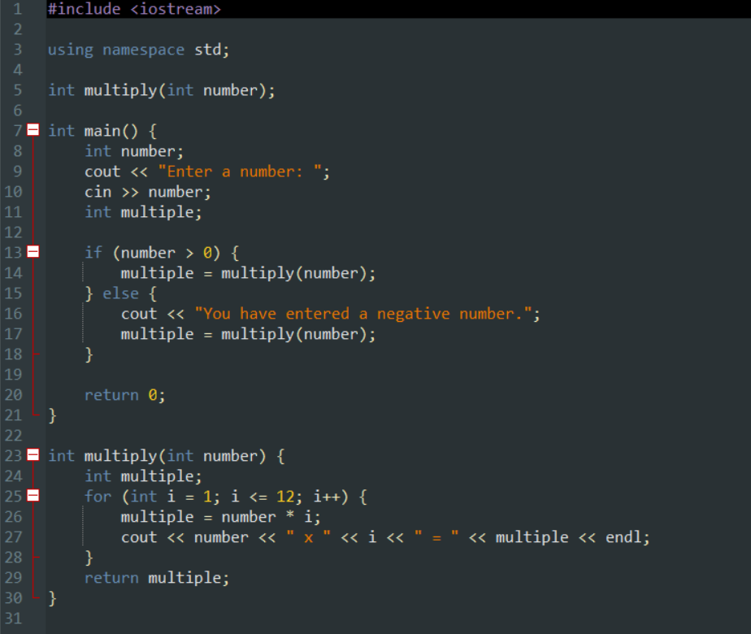

Figure : Code for Tute 01

Figure : Output for code